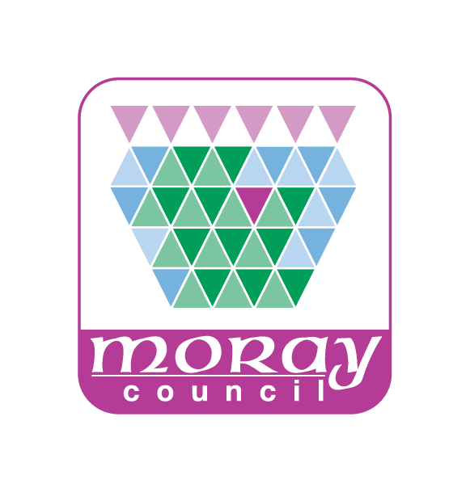
2025 Employee Survey Headlines

Following on from the 2025 Employee Survey that ran from 10 March – 4 April 2025, the results have been analysed and the headline results are displayed below.

- Response rates
- Highest scoring questions
- Lowest scoring questions
- Areas of improvement, sustained performance and development

Response Rates:

Distribution method | Sent out | Returns | 2025 Response Rate (%) | 2023 Response Rate (%) | 2019 Response Rate (%) | 2017 Response Rate (%) | 2015 Response Rate (%)
Paper questionnaire | 572 | 71 | 12.4% | 11.2% | 19.4% | 61.4% | 9.5%
Online / electronic survey | 4,755 | 1,480 | 31.1% | 23.9% | 34.4% | 39.4% | 35.2%
Total | 5,327 | 1551 | 29% | 23% | 31% | 42% | 31%

Highest Scoring Questions:

96% It is clear to me what is acceptable and unacceptable behaviour in the workplace
89% I am clear what my duties and responsibilities are
88% I am not subject to harassment in the workplace
86% I am aware of the appropriate channels for reporting unacceptable behaviour, bullying or harassment
86% I enjoy the work I do
85% I feel respected by my colleagues

Lowest Scoring Questions:

21% I believe Councillors provide leadership for the Council
28% I believe that the Council will take action to address issues arising from the survey
39% I know what Councillors do
43% Digital improvements have improved the way I do my work
44% I believe senior management have a clear vision of where the organisation is going
45% Overall, I am satisfied with the leadership and direction I receive
45% Communications from the Council are open and honest

Key Findings

Key Improvements | 2025 % agreeing with statement | 2023 % agreeing with statement | % change since 2023
I am aware of the challenges that face the Council over the next few years | 83% | 73% | +10%
I understand the Council will have to change the way it delivers services because of these challenges | 79% | 73% | +6%
I am kept well informed about what is happening within the Council | 54% | 48% | +6%
I am aware of the appropriate channels for reporting unacceptable behaviour, bullying or harassment | 86% | 81% | +5%
I feel my mental health is sufficiently supported at work | 64% | 59% | +5%
Areas of Sustained Performance
I feel respected by my colleagues | 85% | 85% | No change
My workload is generally manageable | 65% | 65% | No change
I have realistic time available to complete my job | 60% | 60% | No change
I am clear to me what is acceptable and unacceptable behaviour in the workplace | 96% | 96% | No change
I am confident that unacceptable behaviour will be taken seriously and dealt with | 71% | 71% | No change
I am given the proper equipment to keep me safe and protect my health | 82% | 82% | No change
I have a good work/life balance | 72% | 72% | No change
I have been able to maintain and/or improve my mental health and wellbeing during the last year | 59% | 59% | No change
Areas for Development
I believe senior management have a clear vision of where the organisation is going | 44% | 44% | No change
I believe that the Council will take action to address issues arising from the survey | 28% | 28% | No change
Communications from the Council are open and honest | 45% | 45% | No change
Morale is good where I work | 48% | 52% | -4%
My line manager/supervisor motivates me | 65% | 69% | -4%
I am not subject to unacceptable behaviour/bullying in the workplace | 83%* | 89% | -6%
I am not subject to harassment in the workplace | 88%* | 94% | -6%
I enjoy the work I do | 86%* | 89% | -3%

*Please note that those highlighted with an asterisk although demonstrating a decline from the previous survey results remain relatively positive and therefore the focus on areas for development will be on the lower scoring areas or where further consideration is required because of the wider overall analysis.

The next step is to produce a corporate analysis booklet which will be published on the interchange and departmental summaries once the results have been reported to Corporate Committee. The departmental summaries will be issued to each Depute Chief Executive and Head of Service and these will be used to help inform specific areas of action both from within the departments and in conjunction with corporate initiatives such as employee engagement and workforce culture. The outcome of the survey will support informing the direction of the workforce culture work and address any arising issues.

Indicative Timescales:
Corporate Analysis (booklet) – June 2025
Departmental Summaries (spreadsheet style) – June 2025

