
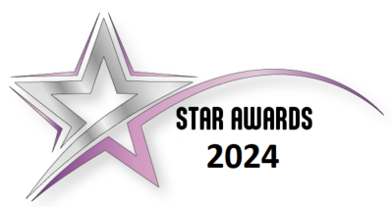
Nomination form 2024

~ THE NOMINATION ~
Suggested Categories –
The headings below are for guidance only. Nominations may also be made under other headings of your choosing.
- Efficiency | - Improvement | - Overcoming Adversity
- Engagement | - Health and Wellbeing | - Support
- Partnership/Collaborative Working | - Customer Service | - Leadership
- Excellence in Health and Safety | - Community/Volunteer | - Diversity/Inclusion
- Good Citizenship (Or Public Spirit) | - Helping/Mentoring | - Going Green

~ ABOUT YOU ~
Name
Work address/location
E-mail
~ WHO ARE YOU NOMINATING? ~
Name of Employee/Team
Team Members (if applicable)
Nominee (s) email address
(GDPR purposes) Required field*
Line Manager
Head of Service
Department / location

~ NOMINATION DETAILS ~
1. Why are you nominating this person/team?
2. How has their work led to improvements within the Council?

3. What is distinctive or exceptional about their contribution?
4. Please attach supporting information to supplement the examples above  (Maximum of 3 pieces permitted) | I have attached:  - ……………………………………………  - ……………………………………………  - ……………………………………………
NB: anonymous nominations will not be accepted

Checklist
Please ensure:
□ You have told us about the individual / team
□ You have told us the individual / team email address if they have one
□ It is clear what the nomination is for
□ You have provided examples of specific outcomes
□ You have included supporting information

Think about:
What makes your nomination stand out?
The result and impact of the subject matter – planning through to the end result.
Describing how the specific contributions / actions of your nominee has had an impact
Reviewing all nomination materials for consistency before submission, it can be a good idea to have a colleague review it before you submit

