EV CHARGING GUIDE
IMPORTANT - This vehicle is intended for ‘back to base’ charging i.e. to be driven within its single charged range and returned to its base location to recharge overnight. Please make an assessment of you range needs and the available range, taking into account that the vehicle may travel approximately 25% less than the shown range due to driving conditions & ambient temperature etc.
Depending on the vehicles base location there are two types of charger available and the charging sequence for each is set out as follows.
Swarco / CPS charge point
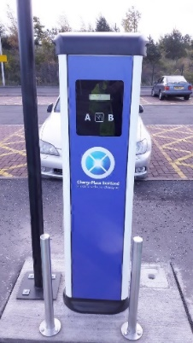
VEHICLE CHARGING PROCEDURE
• Plug the charging cable into the vehicle
• Present the charging access card to the charge post
• The post will authorise the card and ask you to select a charge socket
• Insert the charge cable into the selected socket
• The post indicator light will turn from Green to Blue
• Check that the vehicle is charging – the light at the car charging port will flash green and the information on the vehicle dashboard will show the time to full charge
• Lock the vehicle

TO END CHARGING OR CHARGE COMPLETE
• Unlock the vehicle
• Present the charging access card to the charge post
• The charge post will unlock the cable after a few seconds
• Remove the cable from the post
• Remove the cable from the vehicle & store in the vehicle
• Close the vehicle charge port door

Easee EV Charge point
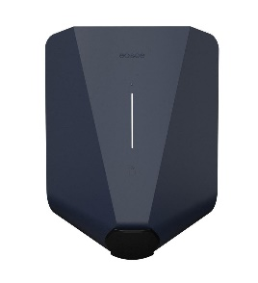
VEHICLE CHARGING PROCEDURE
- Plug the charging cable into the vehicle
- Insert the charge cable into the selected socket
- The post indicator light will turn white to indicate a ready status
- Present the charge card/fob to the post at a point beneath the indicator light
- The light will flash green to indicate an authorised charge
- Check that the vehicle is charging – the light at the car charging port will flash green and the information on the vehicle dashboard will show the time to full charge
- Lock the vehicle
TO END CHARGING OR CHARGE COMPLETE
- Unlock the vehicle
- Remove the charging cable from the car
- Wait 2 seconds then remove the charging cable from the charge point & store in the vehicle
- Close the vehicle charge port door
The council policy is that fleet vehicles do not use public charging infrastructure unless there is a need for a ‘top up’ charge during a journey.
If a top up charge is required then a list of available public charge points is available at https://chargeplacescotland.org/
Should you need a top up charge during working hours but to not have on-line access please contact Fleet Services on 01343 557 317 who will be able to assist. Outside working hours please call the councils out of hours number 03457 565656 who will be able to assist.
Subject to depot opening hours, fleet chargers may also be available at the following locations.
Ashgrove Depot, Elgin, Moray, IV30 1UU
Roads Depot, Bridge St Keith, AB55 5HJ
Grounds Depot, 14 March Rd, Buckie, AB56 4BY

Buckie Access Point, Buckie, AB56 1AJ
Housing Depot, Mosstodloch, IV32 7LH

Moray Council Annexe, Elgin, IV30 1BX

Keith Resource Centre, Keith, AB55 5AH

