Subject:
Changes to your Microsoft Teams Account

Email Body:

Multi Factor Authentication (MFA) is a security feature to verify your identity when accessing online services. It means that a unique security code is required, in addition to your username and password, to access your account.

Over the next 2 weeks, you will be prompted to set up MFA by registering a mobile phone number. This must be done even if you only use Teams on the Council network, as it will safeguard your account from unauthorised access.

If you are prompted to set up MFA, please follow the onscreen instructions – see below for reference. Please be aware, if you do not register within the 2 weeks, your account will be disabled to ensure that it is protected.

If you are not prompted to set up MFA, it means that you are already registered and you do not need to do anything else.

MFA Set Up Instructions

When prompted to set up MFA, you will be asked for some more security information to access your Teams account. You will be asked to provide your mobile number and a verification code will be sent via text message. You must enter this code to complete the set-up of MFA for your account.

The sequence of steps is as follows:

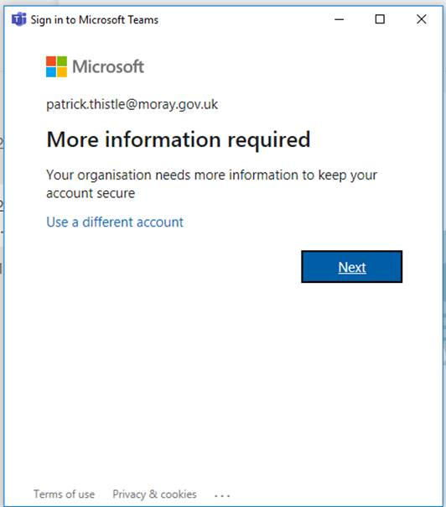

1. Click Next when this box appears.

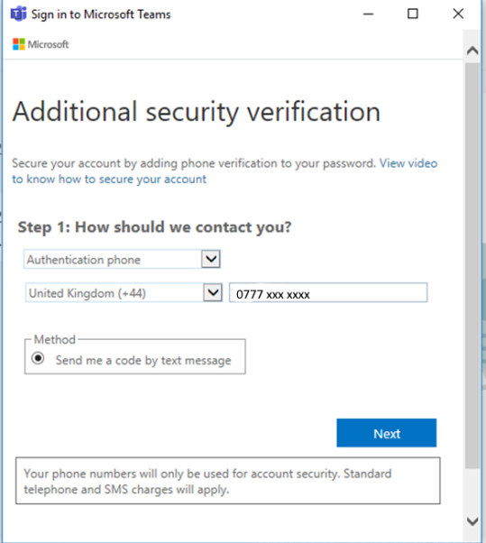

2. Enter your mobile number as above.

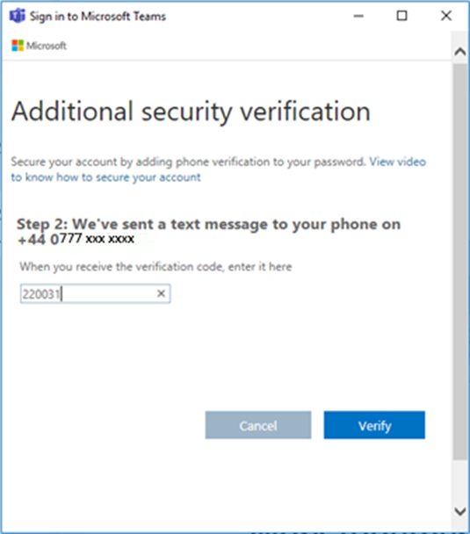

3. When you receive the text code, enter it in the box above.

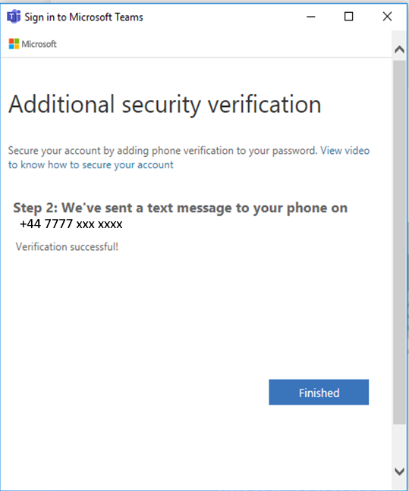

4. Click on Finished to log in.

This email is sent from an account we use for sending messages only. If you need to contact us, don’t reply to this email – we won’t get your response. Instead please use the ICT Servicedesk online form.

