**MORAY COUNCIL**

SUNDRY DEBT POLICY

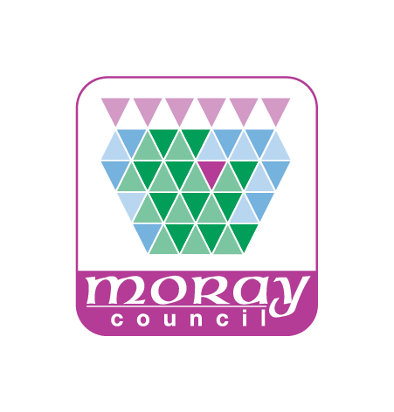

|  |  |
| --- | --- |
| **Date of Creation:** | September 2025 |
| **Owner (Service):** | Chief Financial Officer |
| **Reviewer Head of Service:** | Chief Financial Officer |
| **Approver Executive Director:** | Executive Director for Economy, Enterprise and Operations |
| **Date Approved:** | September 2025 |
| **Approver (Committee):** | Moray Council |
| **Date Approved:** | 24 September 2025 |
| **Next Review Date:** | June 2028 |

**Version History**

| **Version** | **Date** | **Author** | **Changes Made** | **Approved By** |
| --- | --- | --- | --- | --- |
| 1.0 | June 2017 | Daniel Littlewood Assistant Manager (FMS and Banking) | Initial document | Moray Council |
| 1.1 | September 2025 | Daniel Littlewood Assistant Manager (FMS and Banking) | Split policy and process | Moray Council |

SUNDRY DEBT POLICY

INDEX

|  |  |  |
| --- | --- | --- |
|  |  | PAGE NUMBER |
| 1 | INTRODUCTION | 1 |
| 2 | ISSUING ACCOUNTS | 2 |
| 3 | FOLLOW UP PROCEDURE | 3 |
| 4 | DISPUTED ACCOUNTS | 5 |

|  |  |
| --- | --- |
|  | **INTRODUCTION** |
|  |  |
| 1.1 | The purpose of this document is to set out the Council’s policy for Sundry Debt. This excludes Council Tax, Non Domestic Rates, Industrial Site Rents and Housing Rents. The Council approves a policy for Charges for Services and this is periodically updated. The policy for Charges includes considerations relevant to Sundry Debt and these procedures should be read in conjunction with that policy. |
|  |  |
| 1.2 | All Service Departments individually have the responsibility to recover the debt owed, and this policy should be adhered to by all departments when dealing with Sundry Debt. |

|  |  |
| --- | --- |
| **2.** | **ISSUING ACCOUNTS** |
|  |  |
| 2.1 | Where possible, service departments should request payment in advance of the service being paid for or give the option of payment in advance of service delivery and actively encourage this option to be taken up. |
| 2.2 | Departments should only issue invoices for sums that are considered economical to pursue.By way of general guidance, departments should not raise invoices for sums below £15 and staff should have due regard that sums below £250 are not considered economical to pursue via legal action. |
|  |  |
| 2.3 | Before providing a service or work which is to be invoiced, departments should check the Accounts Receivable system to see if there are currently any outstanding invoices for that customer. Departments should seek to avoid adding to existing debt where customers have old debt. |
|  |  |
| 2.4 | Departments should issue invoices promptly, either in advance or within a short time (maximum of 30 days) of the service being provided, to ensure compliance with VAT Regulations. Issue of invoices should be digital by default. |

|  |  |
| --- | --- |
| **3.** | **FOLLOW UP** |
|  |  |
|  | **Payment Policy** |
| 3.1 | The Council’s policy, as stated on the invoice, is that payment is due on the date of issue. However, the Council will give debtors a reasonable time to make payment. |
|  | **Reminders - Standard Debt** |
| 3.2 | Where an account remains unpaid after 21 days, the Finance department will issue afirst reminderto debtors**.** Where an account remains unpaid after 49 days, the Finance department will issue a second and final reminder to debtors. |
|  | **Reminders - other** |
| 3.3 | Where it is known that the debt is to be settled from the estate of a deceased debtor, the reminder process includes an additional step. |
|  |  |
| 3.4 | Where an account remains unpaid after 21 days, the Finance department will issue afirst reminderto debtors**.** Where an account remains unpaid after 35 days, the Finance department will issue a second reminder to debtors. Where an account remains unpaid after 49 days, the Finance department will issue a third and final reminder to the debtor. |
|  | **Referral to collection agency** |
| 3.5 | The Payments Section will review all debts still outstanding after 49 day prior to referral to the External Debt Collection Agency. Wherever possible the Payments Section will contact the debtor to establish reasons for the delay in payment. |
| 3.6 | The Payments Section may agree alternative payment arrangements with the debtor. |
|  |  |
|  | **Instalments** |
| 3.7 | Where the debtor is unable to settle in full by the due date, the Payments Section can agree arrangements for payment by instalments. The Payments Section will agree a schedule of payments and issue to the debtor, setting out due dates and amounts of the payments to be made. |
|  |  |
| 3.8 | The repayment period should be kept to a minimum. |
|  |  |
| 3.9 | If the debtor breaches an agreement, the invoice will be subject to the normal recovery rules and referred to the collection agency. |
|  |  |
|  | **Offsetting** |
|  |  |
| 3.10 | Where it is possible to offset money owed to the Council by a debtor against money owed by the Council to that debtor the Payments Section can initiate the offsetting process. |
|  |  |
| 3.11 | If a debtor owes more than one debt to the Council and it is possible to offset against monies owed by the Council, the Payments section and service departments involved will determine the hierarchy of debt. This will give priority to higher value debts where non-payment could lead to the loss of a debtor’s home or business. |

|  |  |
| --- | --- |
| **4.** | **DISPUTED ACCOUNTS** |
|  |  |
| 4.1 | If debtors dispute the debt they can request suspension of recovery of debt. The Payments Section will suspend the debt on the written request of a supervisory staff member within the department raising the transaction. The request must state the reason for the suspension. |
|  |  |
| 4.2 | Debts will be suspended for a maximum of 60 days. If the debt is still outstanding after 60 days, the Payments Section will raise a credit note and re-charge the relevant departmental budget, unless the department request a longer suspension. Such a request must be authorised by the Head of Service. |